**Big Pattern 2026, Epilog**

On Sunday, January 18, 2026, 40 jugglers performed a *big lemniscate* (correctly pronounced with an accent on the second syllable and an ending that sounds like ‘biscuit’) at the O’Keefe Middle School in Madison, as part of the 35th (minus one for covid) 47th annual Madfest. Lemniscate is a funny math word referring to a figure-8 shape, and the big lemniscate is a club passing pattern involving a whole bunch of jugglers moving steadily through this shape while passing to others along the way. Counting jugglers and props, the version we did on January 18 was trick with 160 moving objects (40 jugglers and 120 clubs)! While the video evidence shows that we did not perform the pattern perfectly (ha!), we did really get it rolling and it was a blast. It’s a super fun group passing pattern where everyone moves and everyone passes to about ½ of the other jugglers. I’ve organized big patterns at Madfest for years, and once at IJA, and I have come to realize they can be a lot of fun for club passers while at the same time being a challenge to set up efficiently so that people can get right to the task. Nothing saps the enthusiasm of a group of jugglers like delays, confusion, and long discussions about where people are supposed to be and what they’re supposed to do to make a pattern happen. This note provides some details that may be helpful to anyone interested in how to set up such a big pattern.

Coming into the weekend, I wanted to be prepared for a variable number of jugglers, and had a sign-up sheet from the first night of Madfest to encourage participation. It’s easier to sort out a pattern’s dimensions when you know the number of jugglers well in advance, but realistically it is pot luck in terms of who will show, so it’s good to be flexible and to be ready to adjust the size quickly. On Saturday night I settled on the number (40), hoping we’d have enough folks turning up for the 11am start, which we did! I needed some time to sort out the dimensions in advance. I had tried a 26-person version at the 2025 Madfest, but that did not go so well as I had the dimensions screwed up[1]. I workshopped a size-corrected 26-person version at the IJA festival in Indiana in summer 2025, which worked, though the room size in that case limited the overall pattern size. The original set up had 22 movers (11 going along each path), and 4 `jokers`, who pass with movers just before they cross the center. In setting up for 2026, I wanted to be flexible with the final number, and so I needed a fast set up simpler than the geometric method I used on the first try. I also realized that with the comfortable 8-count passing rhythm (thanks Dan for calling the beats), that we can get by with just two jokers, one for each path, who rotate about 180 degrees between alternating passes to their respective movers (Since the two jokers need to rotate, I consider that all jugglers have moving roles in the pattern.) Here I give a bit more of detail on the set up that may help in future attempts.

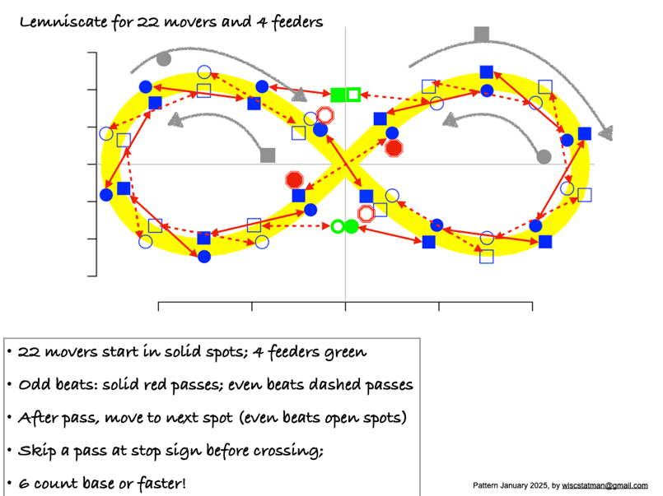

Figure . 22 person lemniscate, 2025 Madfest

Figure 1 summarizes the set up from 2025, involving 22 movers. The edges of that yellow band constitute paths of two groups of jugglers – circles and squares in this representation. The circles are moving counter-clockwise (from above) on the inside of the right-hand loop and they move clockwise on the outside of the left-hand loop. The squares are going on the opposite path and the opposite direction, moving clockwise on the outside of the right loop and counterclockwise on the inside of the left loop. The solid/open shading distinguishes odd beats and even beats; there are basically twice as many spots marked as jugglers, with jugglers moving after each pass into the next position along the respective path. Passes happen between jugglers on the opposite paths. The interesting business is in the crossing of paths, which we enable by having stop-sign positions being the only 4 positions in the pattern which when a juggler gets their the neither pass nor move on the next available beat; i.e. they wait one passing beat for the two jugglers crossing the other way to cross first. I’ll say more about the crossing business later, but first I share a few notes about the pattern set up. **

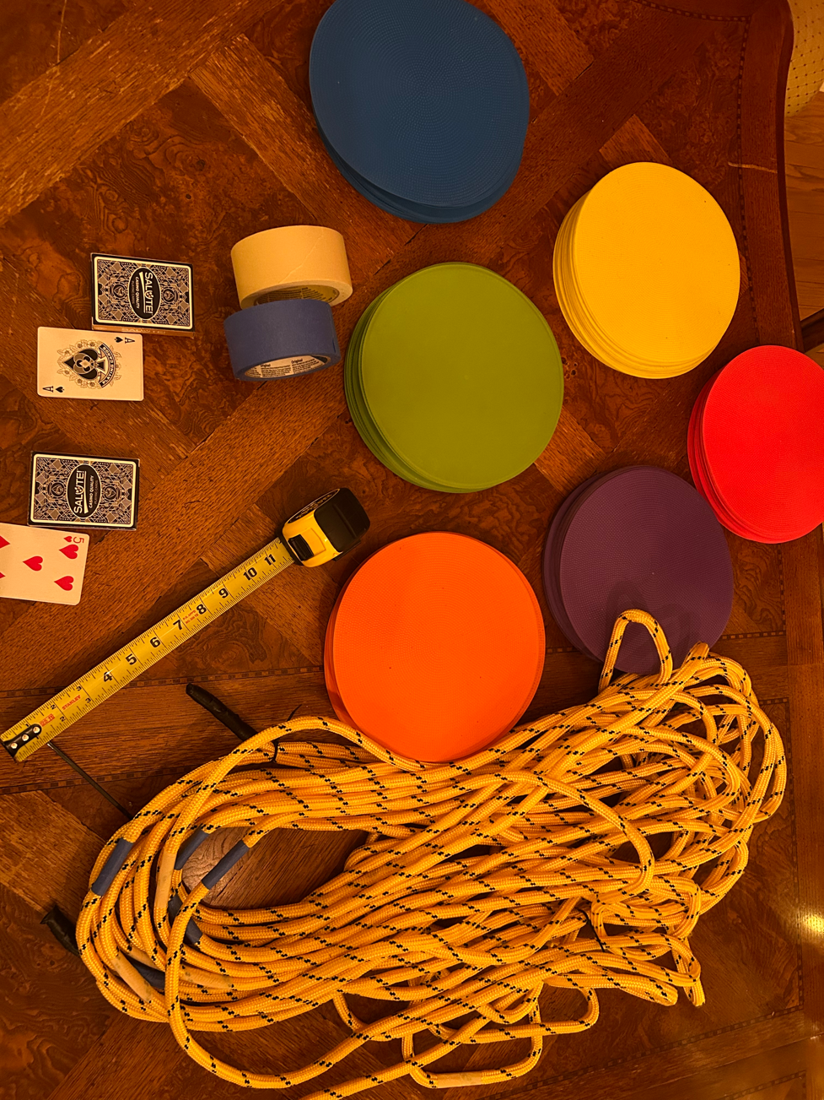

*Pic:* show tools needed for set up: rope, tape measure, tape, floor markers, two decks of playing cards

There’s nothing sacred about 22 movers. The pattern’s crossing and moving rules work as long as you have the same **odd** number of jugglers moving along the two opposite paths. (The crossing rule doesn’t work if you have an even number of jugglers on each path!) We had 19 movers on each path at the 2026 Madfest big pattern (i.e., 38 movers). Each set of 19 splits into two almost equal-sized groups (10 and 9) who populate the two loops (i.e., sides) of their path through the lemniscate. On each loop, 10 were on the outer path and 9 were on the inner. The resulting 4 groups (10/9/10/9) were conveniently labeled ace, two, three…, ten of one suit, ace, two, etc up to nine of another, and so on, covering the four suits. I shuffled one reduced deck of cards and had the 38 participants randomly draw their respective card, which indicated where they would start the pattern. I separately had preset the same cards from a second deck down on the floor. (I have used this device for a number of big patterns, and it’s very convenient to get people where they need to be all at once.)

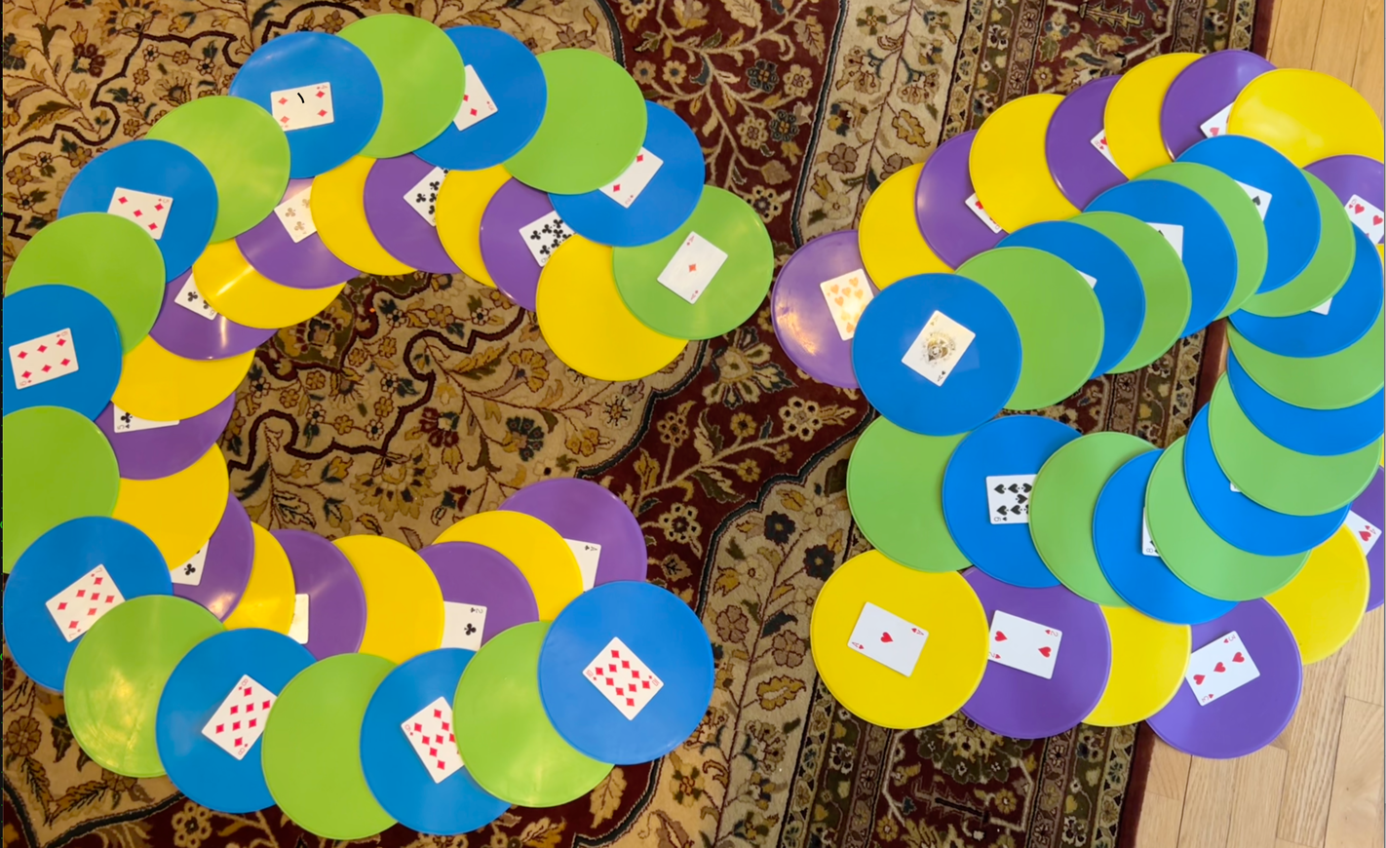

Figure . Living room simulation on the morning before the big pattern. The yellow/purple path is on the inner on the left and the outer on the right; the blue/green path is the opposite, being on the inner on the right and the outer on the left.

**Setting the floor**: The first thing to mark out is the center of the pattern and a square of side-length about 7’, 6’’ (i.e. seven and half feet, or 90’’), the diagonals of which will be paths taken as jugglers cross to the next loop (about 10’, 6” along those diagonals). In my first attempt I had an elaborate geometric construction that allows one to make an almost perfect lemniscate shape *cite*; but that’s a bit restrictive compared to method I used on this last attempt. **describe rope method** 5’ between marks…1-2’ extra off the inner square for a little comfort; 20’’ either side of each mark for the floor markers…placing the cards

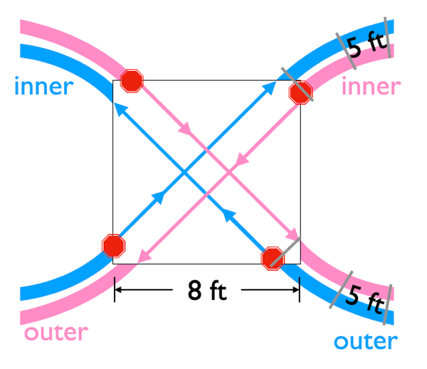

Figure . Crossing detail

**The crossing**: …have a crossing guard…; joker positions

**Metronome and other tricks to make the pattern go**

**160 moving parts**

**?Nathan and a piano roll? What’s the cycle?**

1. The lemniscate shape can be described variously; e.g. locus of points where the product of distances to two fixed points is constant is one way. And there’s another way based on `pedal` functions. It turns out that the foci of the shape in one case are at its edges and in the other case are interior; I mixed them up in my preparations for the first big pattern attempt (in Jan 2025), which meant everything was too small by a factor of about square root of 2!